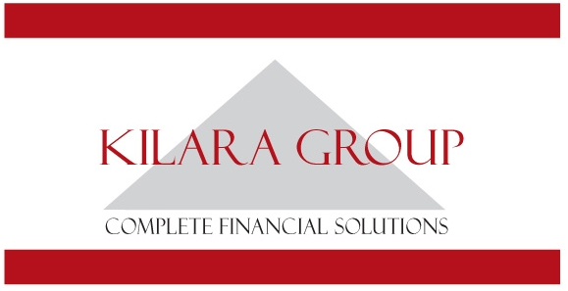
Reception/Administration Assistant
6 Month Contract

We are seeking to employ a highly motivated person to assist with all facets of administration at our Corowa office. This is a 6-month contract covering April to September 2022, with the opportunity of ongoing employment.
This is a full-time position that would suit a candidate with experience working in a professional practice.
The role requires:
- Advanced knowledge of the MS Office Suite
- Friendly, welcoming phone manner and great communication skills
- Ability to co-ordinate workflow, work to deadlines and follow established procedures
- High attention to detail and accuracy
- Someone who thrives on working in a team environment

Remuneration will be dependent upon skills and experience.

To take advantage of this exciting opportunity, please email your resume to kg@kilara.com.au or mail to PO Box 115 Corowa NSW 2646.

Applications close 5pm – Friday 25 February 2022.

